Dover Fund Report – Deanna Cunningham 2024
University of St Andrews
31st October 2024

I am incredibly thankful for the generous support from the Dover Fund, which enabled me to conduct essential field visits to the archaeological sites and museums in the region of Kavala during August of 2024. This travel to Greek Macedonia was part of my PhD research at the University of St Andrews. My project, currently under the working title ‘Forgotten Landscapes: The Importance of Networks, topography and Place-making in the Spread and Experience of Christianity in Late Antique Macedonia’, is fundamentally focused on exploring the importance of networks of various kinds – such as the physical, social and material– in the Christianisation of the landscape of Provincial Macedonia in Late Antiquity. As part of this, I am also interested the changing experience of religious, urban and rural life during this period. The sites I visited after receiving support from the Dover Fund included Philippi, Amphipolis and Neapolis (Kavala), all of which, were highly connected nodes in this physical and immaterial network. They had a significant Christian presence early in Late Antiquity, making them central to my research on the complex processes of conversion and Christianisation.
While staying in Kavala, I visited all the cities mentioned above and several museums. These sites included many of the earliest churches of the region and were hugely important for me to see for my research on the monumentalisation and acceptance of Christianity in Macedonia. I was able to record the topographic setting of these sites and satellite churches, including the structure at Kipia, that would have been part of the broader Macedonian religious network. I was also able to see, in person, the types of architecture, columns, and mosaics that made up these church spaces, which make up a significant portion of my database. One of the highlights included visiting the five churches of Amphipolis, all located in the centre of what had once been a Hellenistic city and surrounded by the later Roman wall. The churches had varying degrees of splendour, diverse plans and were built for distinctively different purposes. Furthermore, whilst in Kavala, I was able to see the physical manifestation of the road network that had once connected my sites, the Via Egnatia. Many parts of the Via Egnatia still survive; for example, it runs through the city of Philippi but the largest parts of it remain outside Kavala, facing down from the hills into the harbour city below. On a personal note, it was truly amazing to walk along the same road as the people who created the monumental churches and lived in the cities I am researching.
I want to thank the Dover Fund for their financial support, as it has aided me in seeing and recording the highly significant mosaics, capitals, columns, mosaics, relief works, structures and settings of the churches that feature within my database and make up the body of my various network analyses. Whilst studying these places online has been an accessible gateway into my research, the sizes and scale of these buildings became so much more apparent when I saw them in person. My summer fieldwork in Greece was transformative for my PhD, and I am incredibly thankful to have been given the opportunity by the Dover Fund.

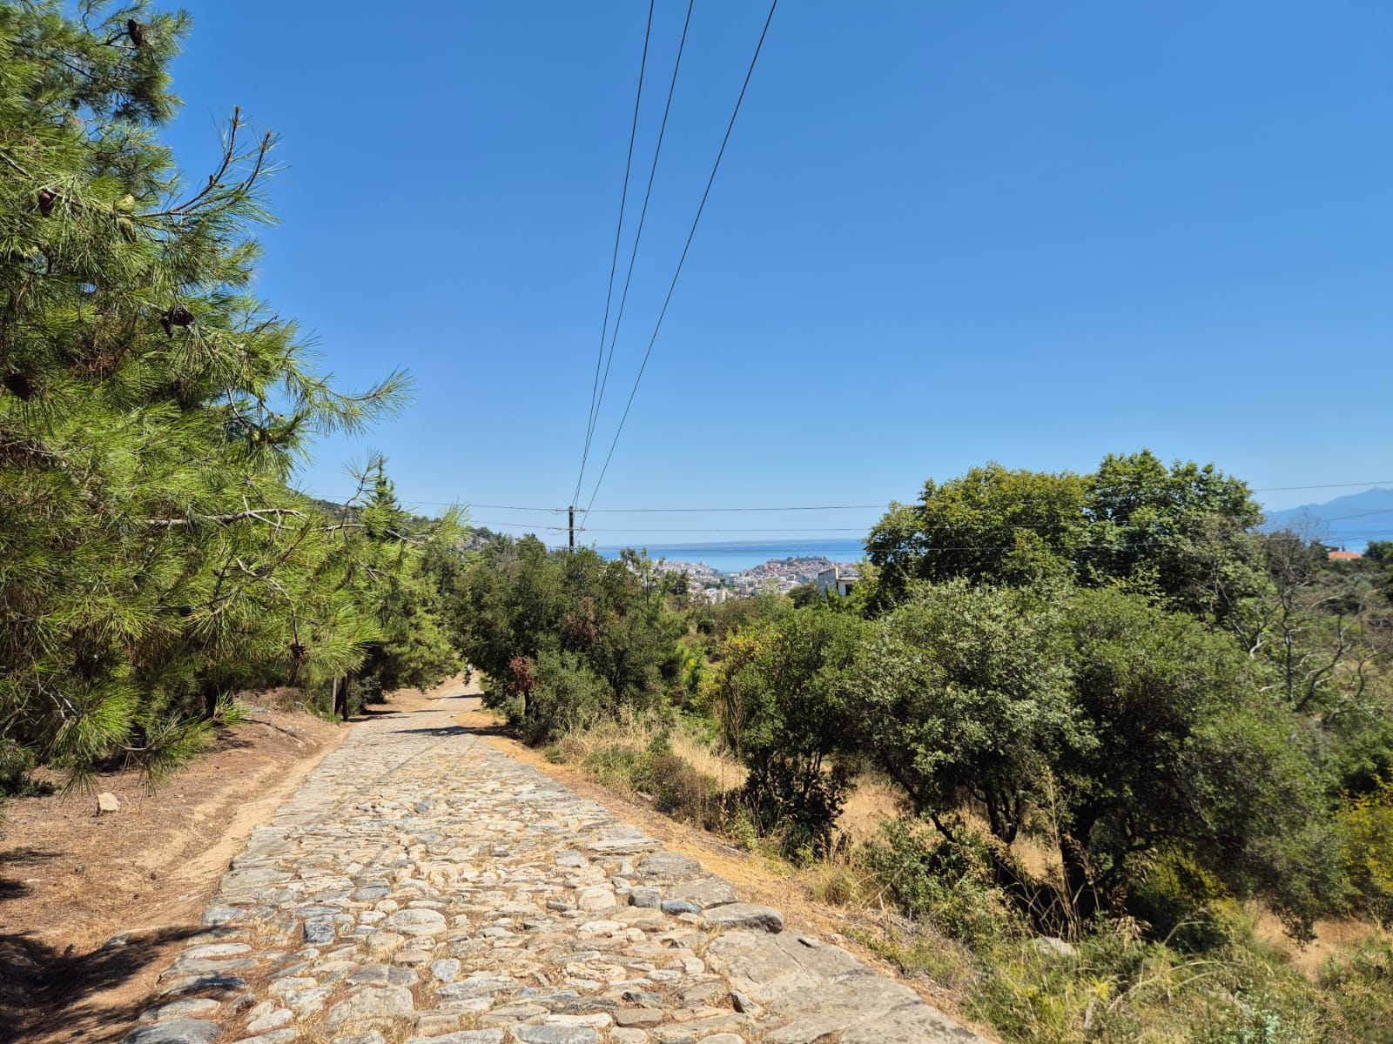
Via Egnatia Roman Road Looking on to the modern city of Kavala and what once would have been Neapolis.

