Social Approaches to Preventing the Looting of Underwater Archaeology in the Ionian Islands – Preliminary Research Trip
Thanks to a grant by the Society for the Promotion of Hellenic Studies, I was able to conduct a week of preliminary research and site visits on the island of Kefalonia in northern Greece. This research is in support of my PhD, which I will soon begin at The University of Oxford, focussing on social approaches to understanding and preventing the looting of underwater archaeology within the Ionian Islands. As I will be returning to the Ionian islands over the next two summers to conduct qualitative interviews with locals and gain an insight into community perceptions of underwater archaeology, I thought it would be essential to familiarise myself with the geography of these islands and the practical realities involved in such a project before I begin in earnest.
Over the course of the week, I was able to visit a range of villages, archaeological sites, and museums throughout Kefalonia. Based in the village of Sami on the east of the island, I began by visiting the Archaeological Museum of Sami. The staff were exceptionally friendly and helpful, and upon learning that I was an archaeologist, kindly gifted me a selection of books and exhibition programmes to assist with my study. I then visited the Museum of Nautical Archaeology in Sami, which is a collection of hand-crafted scale models of the seagoing vessels which have cemented the reputations of Kefalonia and Ithaca as islands of bold and itinerant mariners, starting with Homeric galleys and continuing up to the present day. I next visited the remains of the Roman harbour at Loutro in Sami, where flagstones and masonry emerge from the lapping turquoise waters to give an impression of the architectural outline and character of this ancient port. I finished this first day by hiking up to the Acropolis of Ancient Sami, which commands majestic views across the Sami Bay towards Ithaca.
Keen to delve into local perceptions of underwater archaeology, the next day I went to Agia Effimia and began to ask locals about the community contexts of submerged heritage and if they are aware of any instances of underwater looting, either in the harbour or elsewhere on the island. Virtually everyone I asked hadn’t the faintest idea what I was talking about, and I began to wonder if social approaches to preventing the looting of underwater archaeology might be a red herring (forgive the maritime pun). However, I soon hit the motherload. When I asked in at a local dive shop, and then with local fisherman in the harbour, effusive answers began to pour forth regarding submerged wrecks, undocumented sites, chance finds in fishing nets and foreign ‘hobbyists’ who come to the islands to dive and loot. It soon became clear that within the villages, fishermen and dive shop owners hold the lion’s share of information regarding the location and looting of submerged sites – after all, why would shopkeepers, restaurant owners or waiters know anything of the matter? With this reality established, I expanded my search across the island and visited the villages of Fiscardo, Assos and Argostoli, where similar answers and sentiments were gleaned from conversations with the resident fishermen and dive shop owners.
This trip has been invaluable in establishing some of the ground truths on Kefalonia regarding the phenomenon of underwater looting, and I now have a far clearer idea of the logistics and practical considerations involved in undertaking such a project. I will now be able to refine my research context and methodology during the first year of the PhD based upon firsthand experience of the issue at hand. I will also now be able to think strategically about the next two summers, where I will expand this study across the 6 Ionian islands (excluding Kythera, which is administratively part of the Ionians but geographically in the Aegean) and look to incorporate 3-4 villages per island within my analysis. I sincerely thank the SPHS for their financial support and look forward to conducting this research over the next 3 years.

Best wishes,
Liam Devlin
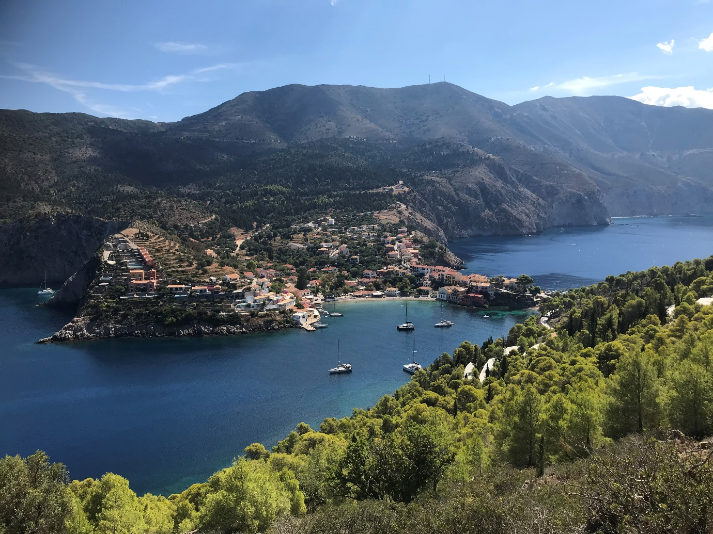
The Village of Assos

